ECSEL JU Pilot Lines Success Stories & Impact

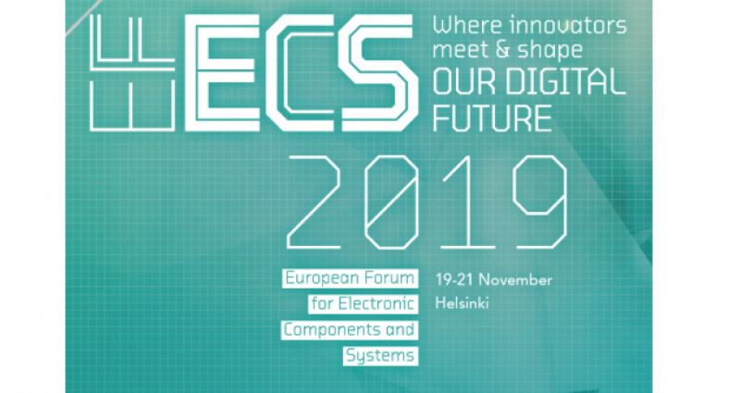

**ECSEL JU Pilot Lines Success Stories & Impact side event at EFECS 2019 in Helsinki**

**November 19th from 10:00 to 12:00, Helsinki hall.**

Key enabling technology (KET) pilot lines are large technology oriented projects with industrial leadership. Their main objective is to develop innovative technologies through a realistic production environment (pilot line) for early adoption by the electronics industry on the downstream value chain.

The ECSEL JU Pilot Lines Success Stories & Impact side event, taking place during the EFECS 2019 in Helsinki, will focus on recent supported projects to highlight the positive impact they bring in terms of scientific excellence and exploitation in the whole value chain of the European semiconductor industry. Some key players of ECSEL JU pilot lines will testify on the main outcomes of these projects through short pitches.

The registration to this side event is now open - you can register [here](https://forms.office.com/Pages/ResponsePage.aspx?id=0fqKviEz3UOHJTRz0calnko-JaHCrC9Oi2UQA-MFP3xUNFlMTFczUERLQk0xQVYzQkpDNEhQRUlEMy4u).

Sponsors and participants: STMicroelectronics, CEA-LETI, TU Darmstadt, SOITEC, GLOBALFOUNDRIES, LYNRED, BOSCH, ECSEL JU

You can find the programme of the event [here](https://www.ecsel.eu/sites/default/files/2019-11/20191119_ECSELPilotLine_Impact_session_Proposal.pdf).